**SYSTEM DESIGNING OF SPHOORTHYS PROJECT BOARD**

**CONTENTS**

|  |  |  |
| --- | --- | --- |
| **SNO** | **TOPIC** | **PAGENO** |
| **1** | **INTRODUCTION**   * 1. PURPOSE   2. SCOPE   3. OVERVIEW | **1**  1  1  1 |
| **2** | **SYSTEM OVERVIEW** | **2** |
| **3** | **SYSTEM ANALYSIS**  3.1 INTRODUCTION  3.2 ANALYSIS MODEL  3.3STUDY OF SYSTEM  3.3.1 MODULUS  3.3.2 MODULE DESCRIPTION | **3**  3  3  3  3  3 |
| **4** | **SYSTEM ARCHITECTURE**  4.1 UML DIAGRAMS  4.2 TYPES OF UML DIAGRAMS  4.2.1 STRUCTURAL DIAGRAMS  4.2.2 BEHAVIORAL DIAGRAMS  4.3 USE OF UML DIAGRAMS  4.4 USE CASE DIAGRAM  4.5 CLASS DIAGRAM  4.6 DESIGN RATIONALE  4.6.1 ER DIAGRAM  4.7 DECOMPOSITION DESCRIPTION  4.7.1 SEQUENCE DIAGRAM  4.7.2 ACTIVITY DIAGRAM  4.7.3 DATA FLOW DIAGRAM | **4**  4  5  5  5  6  7  8  9  9  10  10  11  12 |
| **5** | **COMPONENT DESIGN**  5.1 OBJECT DIAGRAM | **13**  13 |
| **6** | **REQUIREMENT MATRIX** | **14** |

**LIST OF DIAGRAMS**

|  |  |  |
| --- | --- | --- |
| **SNO.** | **DIAGRAM** | **PAGENO.** |
| 4.4.1 | USE CASE DIAGRAM | 7 |
| 4.5.1 | CLASS DIAGRAM | 8 |
| 4.6.1.1 | ER DIAGRAM | 9 |
| 4.7.1.1 | SEQUENCE DIAGRAM | 10 |
| 4.7.2.1 | ACTIVITY DIAGRAM | 11 |
| 4.7.3.1 | DATA FLOW DIAGRAM | 12 |
| 5.1.1 | OBJECT DIAGRAM | 13 |

1. **INTRODUCTION:**

This documentation provides the entire details of the project contents, basic information about the project, the services, differentiates the existing system with the proposed system and also concentrates on the future enhancement by providing a prototype which can be applied to any product.

**1.1 PURPOSE:**

The software design document is intended to design the features of Sphoorthy’s Project Board into a document visual in which issues of how the project will work and generation of different kinds of reports.

The people for which this document was prepared are:

* Students
* Faculty
* Head of the department
* Management
  1. **SCOPE:**

The product which we are producing is “Sphoorthy’s Project Board”. Activities performed by our product

* Maintain the information about the projects
* Showcasing the best projects
* Extension of any project is possible are not
* Students can refer this for getting project ideas
  1. **OVERVIEW:**

In the play store there are many apps which fulfill the above problems in the various ways. These projects tend to charge some amount for obtaining the details about a respective project. The android may feature some of the features like giving overview of the idea and the platform used etc, but doing so it would develop a big scrolling screen output which may take time to search for a proper idea and also can be a time consuming task.

**2. SYSTEM OVERVIEW:**

In this project we trying to create an augment app where we will tend to display the project’s information completed by the seniors just by scanning the logo of the respective project where we try to display the project’s overview, achievements, videos, photos and contacts of the people who did the project if the respective information available. This would decrease the usage of paper and also makes it more digital project.

**3.SYSTEM ANALYSIS:**

**3.1 INTRODUCTION**

After analyzing the requirements, the next step is to analyze the problem and understand its context. The first activity in the phase is studying the existing system and other is to understand the requirements and domain of the new system. Understanding the properties and requirements of a new system is more difficult and requires creative thinking as well as understanding of existing system is also difficult. Improper understanding of present system can lead diversion from solution.

**3.2 ANALYSIS MODEL**

The model that is basically being followed is PROTOTYPE Model prototype is developed based on the currently known requirements. Prototype model is a software development model. By using this prototype, the client can get an “actual feel” of the system, since the interactions with prototype can enable the client to better understand the requirements of the desired system.

**3.3 STUDY OF SYSTEM**

**3.3.1 MODULES:**

1. Augmented Reality Application
2. Web Application

**3.3.2 MODULE DESCRIPTION**

1. The augmented reality app is used to display the details regarding the project which is identified by project’s logo
2. The web application is used to display the previous projects so that the students can access more number of ideas

**4. SYSTEM ARCHITECTURE**

**4.1 UML DIAGRAMS:**

UML stands for Unified Modeling Language. A UML system is represented using five different views that describe the system from distinctly different perspective. Each view is defined by a set of diagram, which is as follows.

1. User Model View

* This view represents the system from the user perspective.
* The analysis representation describes a usage scenario from the end-user’s perspective.

2. Structural model view

* In this model the data and functionality are arrived from inside the system.
* This model view models the static structures.

3. Model View

It represents the dynamic of behavioural as parts of the system, depicting the interactions of collection between various structural elements described in the user model and structural model view.

4. Implementation Model View

In this the structural and behavioural as parts of the system are represented as they are to be built.

5. Environmental Model View

In this the structural and behavioural aspects of the environment in which the system is to be implemented are represented.

**4.2 TYPES OF UML DIAGRAMS**

The current UML standards call for 13 different types of diagrams. These diagrams are organized into two distinct groups: structural diagrams and behavioural or interaction diagrams.

**4.2.1 STRUCTURAL UML DIAGRAMS**

1. Class diagram
2. Package diagram
3. Object diagram
4. Component diagram
5. Composite structure diagram
6. Deployment diagram

**4.2.2 BEHAVIORAL UML DIAGRAMS**

1. Activity diagram
2. Sequence diagram
3. Use case diagram
4. State diagram
5. Communication diagram
6. Interaction overview diagram
7. Timing diagram
   1. **USES OF UML**
8. Modeling the business process
9. Describing the system architecture
10. Showing the application structure
11. Capturing the system behaviour
12. Modeling the data structure
13. Building the detailed specifications of the system
14. Sketching the ideas
15. Generating the program code
    1. **USE CASE DIAGRAM:**

Use case diagrams consists of actors, use cases and their relationships. The diagram is used to model the system/subsystem of an application. A single use case diagram captures a particular functionality of a system. Hence to model the entire system, a number of use case diagrams are used

The purposes of use case diagrams can be said to be as follows −

* + - Used to gather the requirements of a system.
    - Used to get an outside view of a system.
    - Identify the external and internal factors influencing the system.
    - Show the interaction among the requirements are actors.

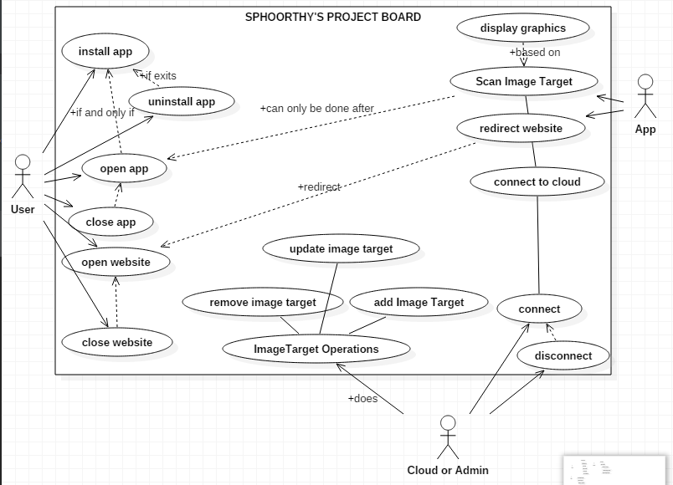

**Fig 4.4.1 Use Case Diagram of our project**

**4.5 CLASS DIAGRAM:**

Class diagram is a static diagram. Class diagram describes the attributes and operations of a class and also the constraints imposed on the system

The purpose of the class diagram can be summarized as −

* Analysis and design of the static view of an application.
* Describe responsibilities of a system.
* Base for component and deployment diagrams.
* Forward and reverse engineering.

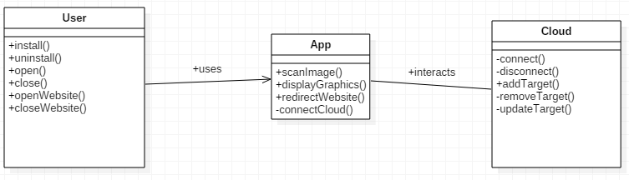

**Fig 4.5.1 Class Diagram of our project**

**4.6 DESIGN RATIONALE**

**4.6.1 ER DIAGRAM:**

Any object, for example, entities, attributes of an entity, relationship sets, and attributes of relationship sets, can be represented with the help of an ER diagram.

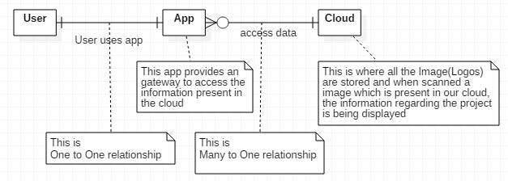**Fig 4.6.1.1 ER Diagram of Project**

**4.7 DECOMPOSITON DISCRIPTION:**Different diagrams including sequence, activity, dataflow, state, transition diagrams are given below.

**4.7.1 SEQENCE DIAGRAM:**

The purpose of interaction diagram is –

* To capture the dynamic behaviour of a system.
* To describe the message flow in the system.
* To describe the structural organization of the objects.
* To describe the interaction among objects.

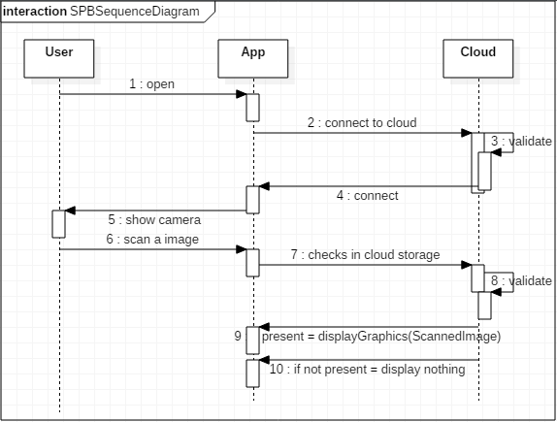

**Fig 4.7.1.1 Sequence Diagram of our project**

**4.7.2 Activity Diagram**

Activity diagram is basically a flowchart to represent the flow from one activity to another activity. The activity can be described as an operation of the system.  
The purpose of an activity diagram can be described as −

* Draw the activity flow of a system.
* Describe the sequence from one activity to another.
* Describe the parallel, branched and concurrent flow of the system.

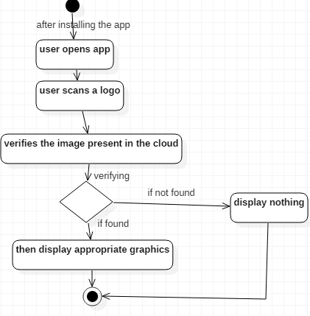

**Fig 4.7.2.1 Activity Diagram of Project**

**4.7.3 DATA FLOW DIAGRAM:**

* A data flow diagram (DFD) illustrates how data is processed by a system in terms of inputs and outputs.
* The DFD is also called as bubble chart.

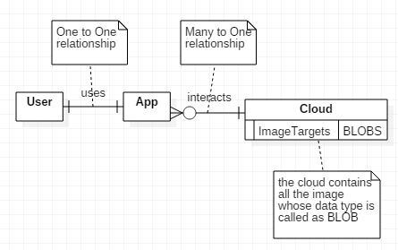 **Fig 4.7.3.1 Data Flow Diagram of Project**

**5. COMPONENT DESIGN**

**5.1 OBJECT DIAGRAM:**

Object diagrams are used to render a set of objects and their relationships as an instance.  
The purpose of the object diagram can be summarized as −

* Forward and reverse engineering.
* Object relationships of a system
* Static view of an interaction.
* Understand object behaviour and their relationship from practical perspective

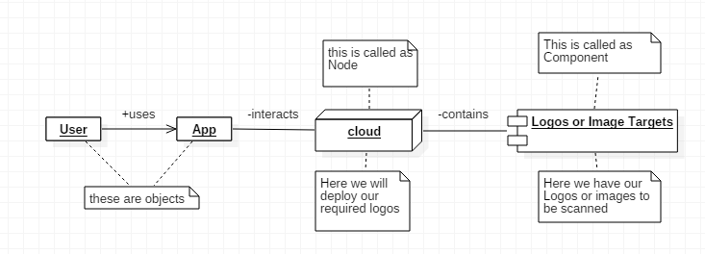

**Fig 5.1.1 Object Diagram of our project**

**6. REQIREMENT MATRIX**

|  |  |  |  |
| --- | --- | --- | --- |
| **PROJECT NAME** | **MAJOR COMPONENTS** | **FUNCTIONAL REQUIREMENTS** | **NON-FUNCTIONAL REQUIREMENTS** |
| **SPHOORTHY’S PROJECT**  **BOARD** | Unity 3D Tool | Scan a Logo | Maintenance |
| Vuforia | If Logo is present in database display respective graphics | Internet |
| Internet | Display the list of projects done in a web browser | Storage Availability |
| Logos and Their Information | Redirect to website if user uses app | Accessibility |
| Wix Editor |